# Prospect Client

## Wednesday, December 13, 20XX

|  |
| --- |
| #1: Your Goals, Objectives and Thoughts on the Future  * Family * Occupation * Recreation * Dreams |
| #2: Our Team  * Wealth Planner, Strategic Planning Analyst, Associate Advisor, In-House CPA * Duncan Financial Group * Coordination with your Team of Professionals |
| #3: Our Comprehensive Approach  * Assess, Evaluate, Protect, and Optimize – Both now and on-going * Wealth Management Approach   + Independence   + Fiduciary Guidance   + Investment Policy Committee   + Alternative Investment Options * Business Owner Planning Strategies |
| #4: Next Steps  * Expectations Moving Forward   + E-mail Proposal from Today   + Schedule “I’ve Got ?’s Call”   + Conduct “I’ve got ?’s Call”   + Final Decision: Go / No Go * Identify Priorities * If you decide to work with us, looking 3 years out, what would you say needs to happen for you to call this successful? |

Presented by: Brian D. Duncan, CFP®

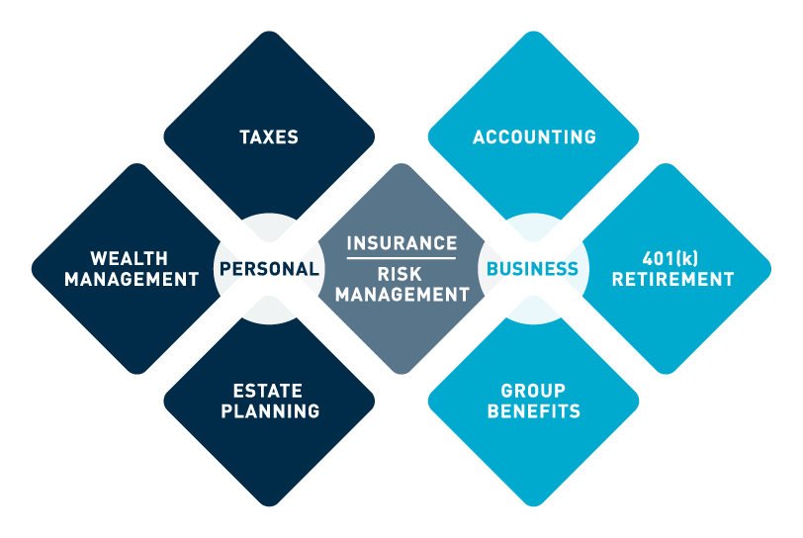THANK YOU FOR YOUR Consideration!